February 2025

ICBA Regulatory Update: Section 1071 – Small Business Loan Data Collection

Topic/Issue: Section 1071

Agency: CFPB

Status: Final rule issued. Compliance dates are staggered, based on loan volume, with dates set forth in June 2024. As of February 2025, however, the Fifth Circuit Court of Appeals stayed those compliance dates for ICBA members until the appeal of the case is finally resolved.
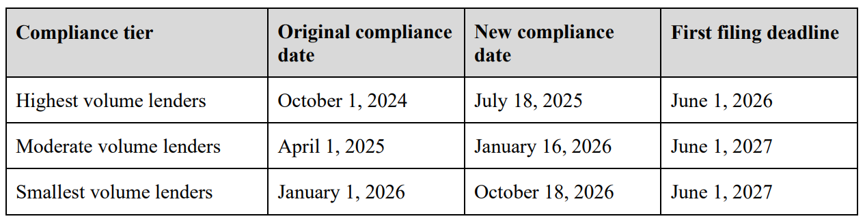

ICBA Position: Section 1071 requires community banks to collect and report data – similar to HMDA –on small business loan applications, including data points on race, sex, and ethnicity of the small business applicant. ICBA is concerned that the requirements are (1) too complex for small community banks, (2) homogenize small business loans, and (3) risk the privacy of small businesses.

Key Talking Points:
Exemption à The smallest community banks will inappropriately be covered by the scope of the rule.
- The CFPB should exclude community banks with assets of $1.3 billion or less.
- Providing partial or full exemptions would still overwhelmingly meet the objectives of the law.

CRA Ratings à ICBA has asked Director Chopra to exempt banks that receive an “outstanding” or
“satisfactory” CRA rating and are considered to be “small” or “intermediate” banks.
- The Bureau has indicated a future rulemaking that will further delay compliance requirements for smaller banks that have performed well on their CRA exams.

Privacy à The collection and public disclosure of personal data also raises concerns about the privacy of applicants, particularly in smaller communities.
- Community bankers are concerned for their small-business customers that are the only business of their type in their local community, such as the town dentist or auto repair shop.
- Even though the customer’s name would be redacted from publication, publishing specific data points — rather than aggregate data — would provide the means to reidentify loan applicants.
- The CFPB needs to provide a notice and opportunity to comment on which data will be made public.

